Welcome to Workington Amateur Swimming Club (WASC)
Welcome to Workington ASC. This pack is designed to provide our new members with information you need to get started at our club. Any questions or concerns then please speak to our volunteer at the door, who can guide you to the correct person to speak to.
Workington ASC are affiliated with Cumbria ASA under the governing body of Swim England ASA.
The club’s aim is to promote the abilities of any swimmer to a competitive level and to provide an atmosphere where swimming is an enjoyable and social experience.
Details of key committee members can be found on our website https://workingtonasc.com/club-information-4/committee/ including details of our welfare officer if you have any concerns.
We accept any swimmer who can swim one length unaided. We also have a Masters Programme for swimmers aged 17+, who have the option to compete in galas.
What to expect at training sessions
Arrival at the leisure centre
- Please arrive 10 minutes prior to your session time. Be swim ready with a tracksuit or onesie over your swim kit, also bring goggles, swim cap and water bottle. Also bring a towel, so you can dry off before leaving.
- We enter the pool from the bottom fire doors, by the outdoor gym. Walk past the main entrance to the end of the building and turn right. You will need to remove outdoor shoes and sanitise hands at the door.
- Spectators can then enter the centre via the main entrance to log your car registration and request access to the balcony viewing area.
Leaving your session
- If you wish to have a shower, then you will need to leave 10 minutes before the end of the session. COLTS squads can all have a shower afterwards.

Swimming etiquette
- Arrive promptly to allow time for warm-up exercises, which will help to avoid injuries
- Ensure you have all the equipment needed (minimum of goggles, towel and water bottle)
- Respect the coaches and volunteers
  - Listen to instructions
  - Be respectful
- The strongest swimmer in each stroke should go first in their lane. No swimmer will be fastest at all strokes.
- If a faster swimmer wants to overtake, then they will touch your foot to indicate they would like past. Move to the side at the end of the lane whilst they pass.

Our Squads
Our less experienced swimmers start in our COLTS squad, where they receive excellent competitive learn to swim coaching from our volunteer coaching team. Each of whom have experience in supporting less confident individuals. The swimmers will move up through several COLTS squads, before progressing to Junior Development (JD), then up into F squad and onwards as they develop.
Once in JD squad, and above, additional equipment will be required. This can be borrowed from the club initially, but ideally swimmers should have their own. This is stored in an individual kit bag in the equipment room poolside. For advice on which kit to buy then please speak to any of the coaching team.
The current training schedule can be found on our website https://workingtonasc.com/club-information-4/fees-and-joining-info/ Please note COLTS usually swim term-time only, although the coaches may choose to continue through the summer holidays. Payments are still taken monthly throughout the year.
We also offer land training to supplement the swimmer's fitness, via Zoom. Details of this can be found on our website https://workingtonasc.com/club-information-4/land-training-for-swimmers/ At some point in the future, we are hoping to offer one session of land training per week at the leisure centre.
Progression through the squads.
CoLTS 1 to 6 (Competitive Learn to Swim)
JD Squad (Junior Development)
G Squad (not currently used)
F Squad
E Squad
D Squad
C Squad
B Squad
A Squad

Communication

Team Website
https://workingtonasc.com - new joiner form can be completed on our website.
Here you’ll find lots of useful information about our club.

Stack Team App
This is used to communicate with coaches and committee to ask general questions and notify absences. Please do let us know if your swimmer can’t attend a session. Information on how to use this app can be found at the end of this pack.


Swim Manager
Can be accessed via Swim Manager app or https://workington.swimmanager.co.uk/ the latter has more functions. Information on how to join can be found at the end of this pack.
We use this for:
- Storing contact information of our swimmer and their parent/carer
- Squad information including schedule
- Messages from our Head Coach/Club Secretary – these should also be received as e-mails. Please speak to us if this doesn’t happen.
- Attendance
- Gala entries
- Personal best times
- Qualifying times for regional events
- Invoices

Facebook Page
Look for “Workington Swimming Club” and “Cumbria Amateur Swimming Association”

Payments
Once registered on Swim Manager please set up direct debit payments via the “payments” page.
Swim squad session fee payment will then be by monthly variable direct debit (using GoCardless) – further help will be given at the time where needed.
Payment by bank transfer from your banking app is also possible, but direct debit is preferred.
Gala fees and shop orders will generate an invoice which will be taken by Direct Debit. You will receive an invoice to advise you of when the payment will be taken.

Galas
A swimmer will normally start their gala experience with either attending the Cumbria Diddy league (from the age of 9 if invited) or the Workington Club Champs gala (Workington annual club only gala)
Club Champs
- 8yr+ & CoLTS squads swimming 25mtrs in all 4 strokes with options to swim some of the greater distances if agreed by the coach.
- 9yr + swimming 50mtr, 100mtr in all 4 strokes & 100IM (Individual Medley)
- 11yr+ also swimming 200IM, with optional 200mtr in all other strokes and 400, 800 & 1500 Freestyle.
- This gala is not optional as the coaches need to access the swimmer ability, progression and improvements. (Further details later in this document)
Other galas
Swimming at other licensed galas will allow swimmers to gain official times. This gives a goal for improving on their personal best (PB’s) and these can count towards those galas where qualifying times are required.
As swimming galas approach, the entries will open on Swim Manager under “Meets”. Links to the entry requirements for that meet will be available with upper/lower times as appropriate. Gala entries are made by selecting the events your swimmer would like to enter. Once submitted please await a generated invoice and payments will be taken by direct debit.
This link explains the types of galas available and gives a link to a calendar of licensed meets https://www.swimming.org/sport/licensed-meets/

Short course and long course galas
There are two seasons in the calendar year. Short-course season is Aug-Dec and Long-course is Jan-Jul. Short course events are held in 25 metre pools, i.e. Workington, long course events are held in Olympic size 50 metre pools.
The galas we attend can vary and details will be sent via Swim Manager when entries open. However, here is a general list of the main galas throughout the season. We aim to update the exact dates on our website at https://workingtonasc.com/swimmer-information/gala-calendar/ Information packs are also found on the individual swim clubs and Cumbria ASA websites approximately 1-2 months before the galas.
The fastest swimmers may qualify for regional and national swims. Details of qualifying times for your swimmer can be found on Swim Manager. Further details can be found on https://swimnorthwest.org/allevents/category/filter/regional-and-national-competitions/ or by speaking to one of the coaches.
Gala preparation
On the week prior to the gala, you will receive an e-mail with the time your swimmer needs to be on poolside.
Swimmers will need:
- A Workington ASC and a spare swim cap
- Club top or black t-shirt, tracksuits bottoms and spare shoes/sliders for poolside
- Goggles and spares
- Two towels (one for poolside and one for drying)
- Plenty of healthy snacks and drinks – no fizzy drinks, glass bottles or chocolate
- Lunch
- Be prepared to stay for the whole session to support other Workington swimmers
All spare items should be in a small bag that can be carried down to the start blocks for each race so the swimmer has them close by just in case, see club shop for an example.
Nutrition advice for galas can be found on our website https://workingtonasc.com/swimmer-information/nutrition/

Sep | WASC host our President’s Gala open meet (open to all). We encourage all our swimmers to enter this gala. It is a great way to raise funds for our club and meet swimmers from within the county and further afield. Held on Friday evening, Saturday and Sunday and includes long-distance swims (800m and 1500m). Age 9+ (age on last day of gala)
Nov | Stockport level 1 meet – only for those who gain qualifying times. Age 11+ (age as of 31st Dec)
NovDec | Date varies – WASC Club Championships. We require all our swimmers to enter this gala and swim as many events as they can, all for a nominal payment per swimmer rather than event. This allows the coaches and swimmers to see their progress. This is only for Workington swimmers. All ages and abilities.
Dec | Cumbria ASA Winter Meet – venue varies, see Cumbria ASA website (http://www.swimcumbria.org.uk/) for more details. Open meet for age 9+
Dec | SE North West Winter Regional – qualifying times required
Jan Feb | 2 weekends of Cumbria County Championships and Age Groups – only for those who gain qualifying times (http://www.swimcumbria.org.uk/). Age 9+
MarMay & Jun | 3 rounds of ASA Diddy League which are held at different clubs around the county. This is an introduction to competitive swimming, in both individual events and relays for our 9/10/11 year olds. This is an unlicensed meet, so times aren’t recorded. We provide extra training for those swimming approximately one month prior to the start of league, details provided nearer the time.
MarAprMay | Swim England North West Summer Regionals for those who gain qualifying times. Age 11+ (age on 31st Dec that year)
Mar | Stockport Spring level 1 meet (qualifying times required)
Mar | Ulverston Spring Fest at Kendal pool. This is a two-day open meet for swimmers aged 9+
Apr | British Champs – qualifying times required
May | Copeland Graded Gala – an open meet for swimmers aged 9+. This gala is only 100m and 200m races plus 50m freestyle
Jun | Kendal Mint gala is an open meet for swimmers aged 9+
Jul | Sunderland Summer Splash – a chance to swim in a 50m pool in an open meet. For ages 9+
Jul | British Nationals - qualifying times required
Aug | English Nationals – qualifying times required
For further gala details, then please see the organising club/organisations websites.

Club champs and presentation night
Every November/December we hold our annual Club Championships. This gala is only open to Workington swimmers and is an opportunity to showcase swimmers’ development over the year. Events are open to all swimmers and awards are given at our Presentation Night based on the swimmers ranking in age groups 7, 8, 9/10, 11/12 ,13/14, 15/16, 17+ per event. Swimmers are encouraged to enter all events.
Our presentation night, usually held in January, is a social event for swimmers and families to get together and celebrate their performance at Club Champs.
Club shop
We currently have a limited supply of WASC branded, swimwear, t-shirts and other merchandise. You can order these through the Swim Manager or by speaking to one of the club shop team. We are hoping to expand this further with additional merchandise. Please speak to a member of the team with any questions.
Club fundraising/volunteers
We are always looking for volunteers to help the club. We would encourage parents/carers to come along and help at training sessions and on gala days. We have a “Friends of WASC” (our charitable element) who aim to raise funds to support the club. We welcome any fundraising ideas.
We hold an AGM each year where families are invited to attend, and we accept any help with our committee.
Volunteer help is very much appreciated. The following roles are always needed:
- Committee members
- Poolside helpers
- Welcoming swimmers at the door
- Coaches – will be provide training
- Gala judges – will be provide training
- On gala days we need extra help selling tickets at the entrance and refreshments.
- Club support
Achievements and swimmer pathway
Once swimmers start to compete in galas, we award milestones with small certificates, to recognise their achievements. These will be presented in training sessions. We are actively involved in supporting swimmers follow the Swim England Talent Pathway. Selection criteria can be found on the Swim England North West website. Swimmers chosen will be notified by the club, County, Swim England North West or Swim England depending on age and selection.
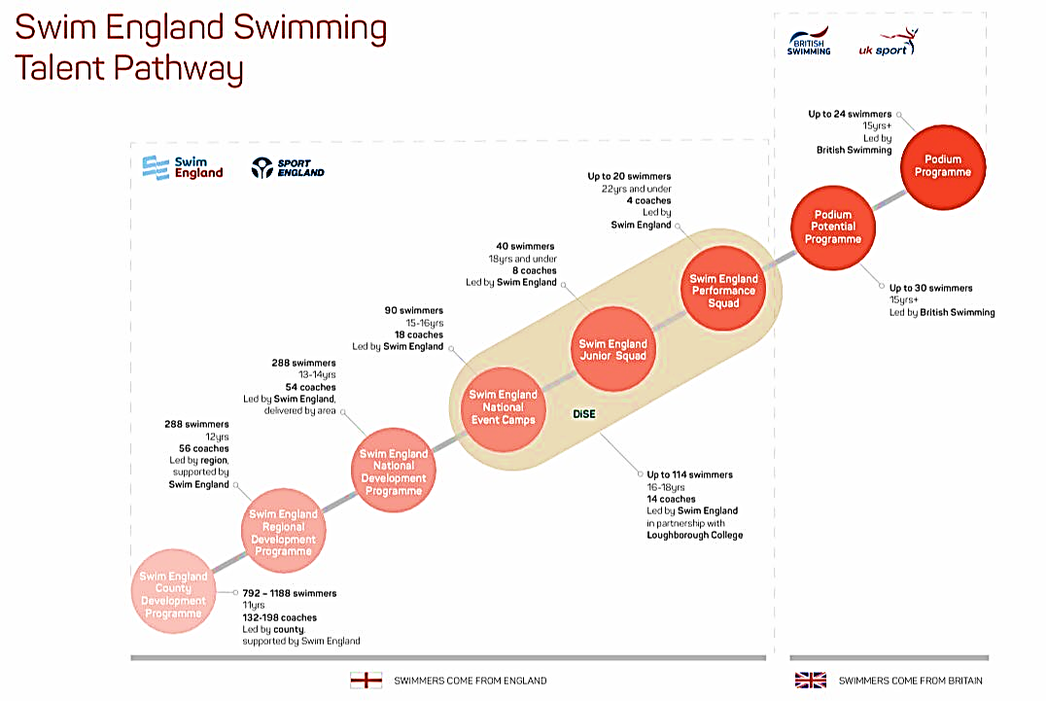

Joining Our Club Tick Sheet
- If you would like to join the club, you can come along for a trial session to be arranged via workingtonasc@outlook.com or 07846 363 973
- Your swimmer will then be assessed and put into a suitable squad based on their ability
- You will be advised of the sessions they are assigned to and the monthly fee applicable
- Please complete the new joiner form on the WASC website https://workingtonasc.com/club-information-4/new-joiner/
- Once your form has been processed you will receive an email from our Swim Manager system for you to register
- Once registered you can access via the Swim Manager app or https://workington.swimmanager.co.uk/
- Visit https://workington.swimmanager.co.uk/ and click “forgotten password.” Follow the directions to set up a password.
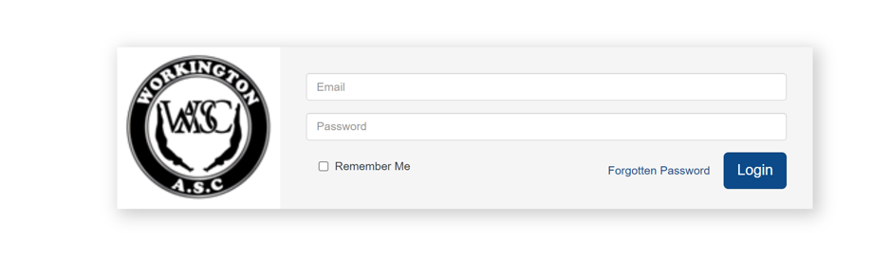
- Once logged onto Swim Manager view “User Guide” at the bottom of the scrolling tab on the left. This will download a user guide as a pdf
- Go to “payments” section and set up Direct Debit
- Please add the email address workington.messages@clubs.swimmanager.co.uk to your contacts, so that the messages are not junked. These emails are generated frequently and will help keep you up to date on what’s happening.
- You will also receive an email from Swim England to register your swimmer for insurance purposes and other benefits. An initial fee of approximately £20-£30 is required depending on whether they are a competing swimmer or not. You’ll receive an invoice once registered.
- Register with Stack Team App
- Search for the Stack Team App on your app store
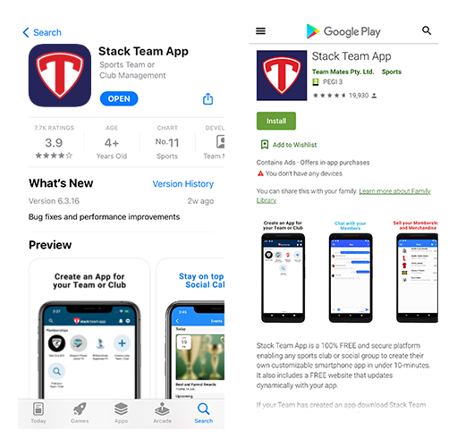
- Click “Find your Team/Club” and search for Workington ASC
- Await verification by our admin team
- Once activated (may take several days) then use the “chat” function to notify of absences or for any general questions.
- Keep an eye out for our e-mails and we hope your swimmer enjoys being part of WASC

As always, any questions just speak to one of the team or email workingtonasc@outlook.com

V2 – updated 8/8/24

